Computer Science 1FC3 Jessica Cao (caoff@mcmaster.ca)
Functions Don Vo (vod2@mcmaster.ca)

Function
- a function assigns one element of one set to each element of another set
- let a be an element in set A and b an element in set B: if b is assigned to a, this is written as f(a) = b
- if f is a function from A to B, we write f: A --> B

Eg. for the function f(x) = x², f(3) = 9, f(5) = 25, f(9) = 81 etc.

There is really nothing new about functions – we’ve been using them in Maple already. Recall the AND function:

[> AND := (x, y) → x and y;

The input to this function, or it’s domain, is the pair of truth values:
(true, true), (true, false), (false, true) and (false,false).
The output of this function, or it’s codomain, is the truth values:
true and false.
If f(a) = b, we say that b is the image of a and a is a pre-image of b.
What is the image of (true, false) for the AND function?
The range of f is the set of all images of elements of A.
What’s the difference between range and codomain? (see graph below)

Real-valued functions with the same domain can be added and multiplied:
(f₁ + f₂)(x) = f₁(x) + f₂(x)
(f ₁ f ₂)(x) = f₁(x)f₂(x)

What do you think is the domain and codomain of (f₁ + f₂) and f₁f₂?

Subset
- if S is a subset of A, the image of S is the subset of B that consists of the images of the elements of S.
- f(S) is the image of S, so that f(S) = {f(s) | s element of S}

One-to-one functions
- also called injective functions
- a function is an injection if and only if f(x) = f(y) implies that x = y for all x and y in the domain of f.
- what is an example of an one-to-one function?

Increasing/Decreasing functions
- a function f is strictly increasing if f(x) < f(y) whenever x < y and x and y are in the domain of f
- what do you think a strictly decreasing function is?

Onto functions
- also called surjective functions
- a function is a surjection if and only if for every element b element of B there is an element a element of A with f(a) = b.
- what is an example of an onto function?

One-to-one Correspondence
- a function is a one-to-one correspondence, or a bijection, if it is both one-to-one and onto.
- what is an example of an bijection?

Inverse function
- assigns to an element b belonging to B the unique element a in A such that f(a) = b
- denoted by f ⁻¹
- f ⁻¹(b) = a when f(a) = b
- what is the inverse function of f(x) = x²?

Composite functions
- the composition of two functions f and g is denoted by f ○g
- (f ○g)(a) = f(g(a))

Exercises

1) For the following functions, state the i) domain ii) codomain iii) image iv) range

a)

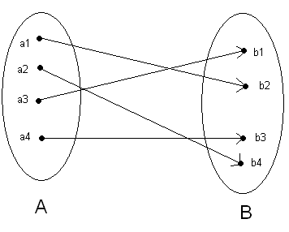

b) f: ℤ→ℤ, f(x) = x + 1

c)
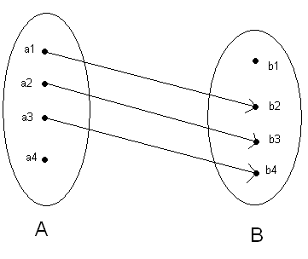
d) f: ℕ→ℕ, f(x) = ⌊100 / x ⌋

2) Describe the following functions as one-to-one, onto, bijective or none of the above.
Does the function have an inverse? If so, find it.

a) f: ℤ→ℤ, f(x) = x – 1 b) f: ℕ→ℕ, f(x) = 2x

c) g: A→B where A = {1, 4, 7, 13, 42} and B = {2, 4, 108, 256} and g = {(1, 108), (4, 256), (7, 2), (13, 4)}

d) g: A→B where A = {10, 42, 64, 111} and B = {2, 4, 108, 256, 720} and g = {(10, 4), (42, 2), (64, 2), (111, 720)}

e) h: A→B where A = {a, b, x, y} and B = {$, #, %, !} and
h = {(a, !), (b, %), (x, $), (y, #)}

f) f: ℝ→ℝ, f(x) = x² + 1 g) f: ℝ→ℝ, f(x) = x³

3) Determine the function that results from the composition, f ∘g.

a) f = x + 2, g = x⁴ b) f = 2x + 2, g = x/2

c) f = x² + 4x + 3, g = (x² – 5)/(x + 13)

