Intensity based image registration with a guaranteed one-to-one point match

B. Fischer(1), J. Modersitzki(2)
(1,2) Institute of Mathematics, University of Lübeck, Lübeck, Germany

Corresponding author:
Bernd Fischer
Institute of Mathematics
University of Lübeck
Wallstrasse 40
23560 Lübeck
phone: 0451-7030-434
FAX: 0451-7030-436
mail: fischer@math.uni-luebeck.de

Summary
Objectives: In this paper, we propose a novel registration technique, which combines the concepts of landmark and automatic, non-rigid intensity based approaches. A general framework which might be used for many different registration problems is presented. The novel approach enables the incoorporation of different distance measures as well as different smoothers. Methods: The proposed scheme does minimize a regularized distance measure subject to some interpolation constraints. The desired deformation is computed iteratively using an Euler-scheme for the first variation of the chosen objective functional. Results: A fast and robust numerical scheme for the computation of the wanted minimizer is developped, implemented, and applied to various registration tasks. This includes the registration of pre- and post intervention images of human eye. Conclusions: A novel framework for parameter-free, non-rigid registration scheme which allows for the additional incorporation of user defined landmarks is proposed. It enhances the reliability of conventional approaches considerably and thereby their acceptability by practitioners in a clinical environment.

Keywords: Image processing (L01.700.568.110.308) Numerical Analysis (L01.700.568.110.680.700), Image registration, Elastic Matching, Landmark Registration

1. Introduction

Image registration is an often encountered problem in medical application. For an overview we refer to Refs. [1, 2, 3, 4], and references therein. Registered images are now used routinely in a multitude of different applications, such as the treatment verification of pre- and post-intervention images and the time evolution of an agent injection subject to patient motion. They are also useful to take full advantage of the complementary information coming from multimodal imagery, like, for example, computer tomography (CT) and magnetic resonance imaging (MRI).

Two fundamental approaches are popular in today image registration. One is based on the detection of a number of outstanding points, the so-called landmarks, and the second one is an intensity based approach minimizing an appropriate chosen distance measure. For the landmark based registration, one has to identify a number of landmarks. Furthermore, one has to choose a regularization term, where typically the thin-plate-spline (TPS) regularizer is used; cf., e.g., [5, 6]. The intensity based registration technique relies on two ingredients: one is a distance measure D and the other one a regularizer S. The regularizer is needed since the problem is ill-posed; i.e., small changes in the images (input data) may lead to large changes in the resulting spatial deformation (output data). For example, consider the registration of two identical discs. Here, any rotation would be a solution and any small perturbation in one of the images would lead to a different rotation (for details, see [7]).

In comparing the two methods, one does encounter a method inherent dilemma. Using a landmark based registration technique, one is able to guarantee a one-to-one match for the user defined landmarks. However, the overall registration might be visually unpleasing, as the scheme solely makes use of the landmarks. On the other hand, although the intensity based approach produces in general visually pleasing results, there is no guarantee, that there is a one-to-one correspondence between the landmarks, as the scheme ``does not know'' about the landmarks.

In this paper, we propose a novel registration technique, which combines the concepts of landmark and automatic, non-rigid distance measure based approaches (CoLD registration). Roughly speaking, the idea is to minimize a regularized distance measure subject to some interpolation constraints. It is important to note, that the presented technique does work for any (sensible) intensity measure, i.e., the user may choose his application dependent favourite intensity measure. Moreover, we present a fast and robust numerical scheme for the computation of the wanted minimizer. Here, the desired deformation is computed iteratively using an Euler-scheme for the first variation of the chosen objective functional (cf. e.g., [7]). The deformations are restricted to fulfill the interpolation constraints. Consequently, the CoLD registration guarantees that each intermediate iterate and in particular the final stationary solution do produce a one-to-one correspondence of the prescribed landmarks. At the same time the whole process is minimizing an intensity based measure for the remaining parts of the images. The computational overhead in our implementation introduced by the consideration of landmarks is negligible as compared to the conventional scheme without landmarks.

There are already some attempts in the literature to design registration schemes which are based on matching both landmark and intensity information; see, e.g., Refs. [8, 9]. However, they are all restricted to special functionals and are not as versatile as the proposed framework.

2. Method

In this section we set the mathematical framework and briefly introduce the landmark based and intensity driven approaches. Finally, we describe our new approach and discuss its basic ideas.

Given are two images, typically called the reference and the template . The goal is to find a spatial deformation , such that the deformed template matches the reference image. There are various ways of computing a suitable displacement. Let us start with intensity driven approaches. Here, one attempts to minimize an appropriate functional,

It typically has two building blocks. The smoother computes internal forces, which are defined for the wanted displacement field itself, whereas the distance measure is responsible for external forces, which are computed from the image data. The internal forces are designed to keep the displacement field smooth during deformation, while the external forces are defined to obtain the desired registration result. The parameter may be used to control the strength of the smoothness of the displacement versus the similarity of the images. Note that the second term is unavoidable. Arbitrary transformations may lead to cracks, foldings, or other unwanted deformations. It turns out that most of these schemes may be formulated in this fashion; see, e.g. Ref.[10].

The actual choice of and depends on the application under consideration. A popular choice for the distance measure is the sum of squares of intensity differences (SSD)

.
It is a reasonable measure for some applications like the serial registration of histological sections. Another choice is provided by the mutual information (MI) related measure. It appears to be the most successful similarity measure for multimodal imaginary, like MR-CT. Typical examples for the smoother include the elastic matching approach

.

The idea is to resemble the properties of the acquisition, like for example the elastic behavior of a human brain. In the above formula, the constants and reflect material properties. For an overview we refer to [7].

Let us now briefly introduce the landmark based approach. To this end, let the landmarks be given. The idea is to find a smooth displacement u such that is mapped onto . Again, a regularizer is incorporated in order to ensure smoothness of the solution. Altogether, we end up with the following scheme. Find a displacement, such that

As it is apparent, the distance between and is no longer part of the functional. The images enter into the scheme only through the landmarks. As for the intensity based registration, we have two building blocks. The internal forces which control the smoothness of the wanted displacement and the external forces, which arise now from the locations of the landmarks.

Having the outlined landmark and intensity based approaches in mind, it is almost obvious how to combine them both to obtain the new CoLD scheme. It can be thought of computing a displacement that minimizes the combination of a intensity measure and a smoother while being guided by the landmark correspondences. Again, the internal forces are used to keep the displacement smooth, while the external forces are now a combination from landmark and intensity information. The mathematical description of the problem reads as follows. Find a displacement, such that

3. Computing a Solution

To compute a minimum of the above minimization problem we apply the calculus of variations, that is we compute the derivative of the associated functional and subsequently seek for stationary points of the derivative. This leads to a system of non-linear partial differential equations for the wanted displacement field :

where the so-called force is related to the derivative of the distance measure and the partial differential operator to the derivative of the smoother . The s denote appropriate Lagrange parameter and is the point-evaluation functional (for details, see [7]).
After invoking a time-stepping approach and after an appropriate space discretization, we finally end up with a system of linear equations. As it turns out, these linear systems have a very rich structure, which allows one to come up with very fast and robust solution schemes. It is important to note that the system matrix does not depend on the force field and the constraints. Thus, changing the similarity measure or adding additional constraints does not change the favorable computational complexity. Moreover, fast and parallel solution schemes can be applied to even more reduce the computation time.

4. Example

In this section we present an example which does compare the new approach to the ones based solely on landmarks and the ones based on a non-rigid registration without landmarks.

Fluorescein angiography (FA) is an extremely valuable tool that provides information about the circulatory system and the condition of the back of the eye. FAs are useful for evaluating many eye diseases that effects the retina; cf. e.g., [11]. Based on FA, the necessity and eventually the success of a treatment of the an eye has to be qualified. To this end, a pre- and a post-intervention image of the eye are taken (cf. Fig. 1(a) and (b)). However, an objective qualifying is a tricky business since the eye can almost never be imaged from the same view point. Thus, beside the differences introduced by the intervention, the images shows differences due to distortions (cf. Fig. 1(c)).

An obvious idea is to identify landmarks (e.g., bifurcation points of vessel)and to perform a landmark based registration (cf., e.g., [6]). Results of the registration are shown in Fig. 1(d) (transformed template) and Fig. 1(g)(difference image). This result clearly indicates that this registration is insufficient.

Fig. 1(e,h) depicts the transformed template after an intensity based registration and the distance measure, respectively. Though the energy in the distance image has been reduced considerably, the overall registration result is insufficient. This is because finer structures like vessel which are of enormous importance for the qualifying are hardly effected.

Finally, Fig. 1(f,i) shows the results of the CoLD approach. As it is apparent from these figures, the CoLD approach is superior. Due to the guaranteed one-to-one correspondence of important bifurcation points, one obtains a perfect initial position and overall registration result. Here, we used eight landmarks and a thin-plate spline approach. The intensity based registration as well as the CoLD approach is based on SSD as distance measure and the curvature functional as smoother. For comparison reason, the parameters are not tuned (we simply used ) and the schemes are terminated after 10 iteration.

5. Conclusions

We have proposed a novel framework for parameter-free, non-rigid registration scheme which allows for the additional incorporation of user defined landmarks. It enhances the reliability of conventional approaches considerably and thereby their acceptability by practitioners in a clinical environment.

It has been shown that the new approach does compute a displacement field which is guaranteed to produce a one-to-one match between given landmarks and at the same time minimizes an intensity based measure for the remaining parts of the images. Moreover, its complexity is comparable to the one for a conventional registration scheme without additional landmarks. Finally, this approach may also be used to derive a good starting guess for the desired displacement, which may save computing time and may prevent a scheme for trapping into unwanted minima.

References

1. Brown LG. A survey of image registration techniques. Computing Surveys 1992:24(4):325-76.

2. Maurer CR, Fitzpatrick JM. Interactive Image-Guided Neurosurgery. Chapter: A Review of Medical Image Registration, pages 17--44. Park Ridge, IL, American Association of Neurological Surgeons, 1993:17-44.

3. van den Elsen PA, Pol EJD, Viergever MA. Medical image matching -- a review with classification. IEEE Engineering in Medicine and Biology, 1993:26--38.

4. Maintz JBA, Viergever MA. A survey of medical image registration. Medical Image Analysis 1998:2(1):1--36.

5. Bookstein FL. Principal warps: Thin-plate splines and the decomposition of deformations. IEEE Transactions on Pattern Analysis and Machine Intelligence 1989:11(6):567-85.

6. Rohr K. Landmark-based Image Analysis. Computational Imaging and Vision, Kluwer Academic Publishers, Dordrecht, 2001.

7. Modersitzki J. Numerical Methods for Image Registration. Oxford University Press, Oxford, 2004.

8. Hellier P, Barillot C. Coupling dense and landmark-based approaches for non rigid registration. Technical Report 1368, INRIA, France, 2000.

9. Johnson HJ, Christensen GE. Consistent landmark and intensity-based image registration. IEEE Transactions on Medical Imaging 2002:21(5):450-61.

10. Fischer B, Modersitzki J. A unified approach to fast image registration and a new curvature based registration technique. Preprint A-02-07, Institute of Mathematics, Medical University of Lübeck, 2002, to appear in Linear Algebra and its Applications.

11. Roider J, Michaud NA, Flotte TJ, Birngruber R. Response of the retinal pigment epithelium to selective photocoagulation. Arch Ophthalmol 1992:110:1786-92.

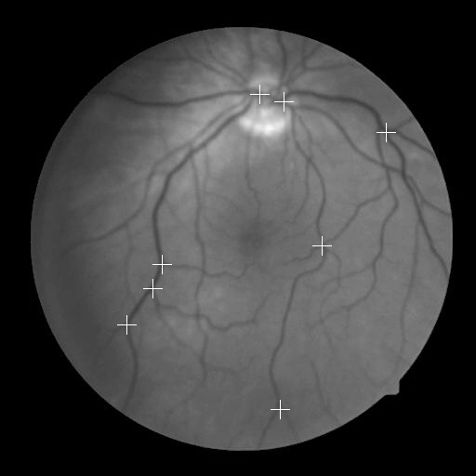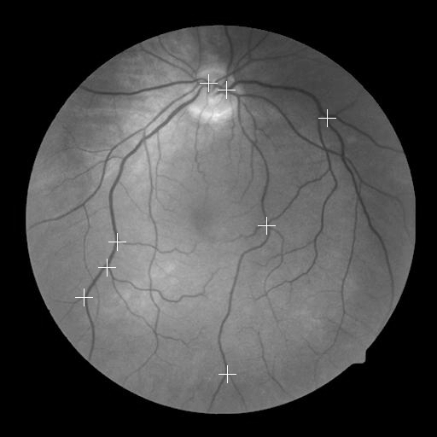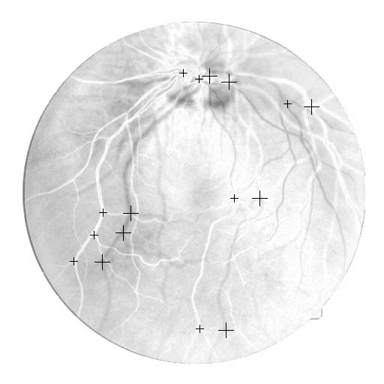

Fig. 1(a) Fig. 1(b) Fig. 1(c)

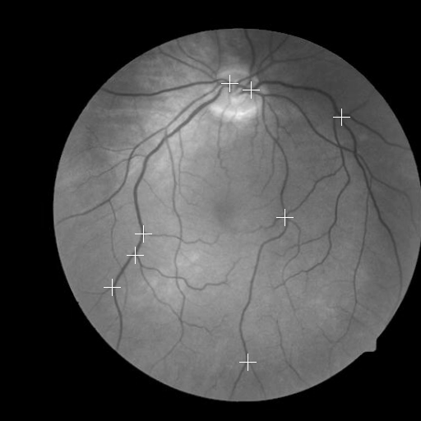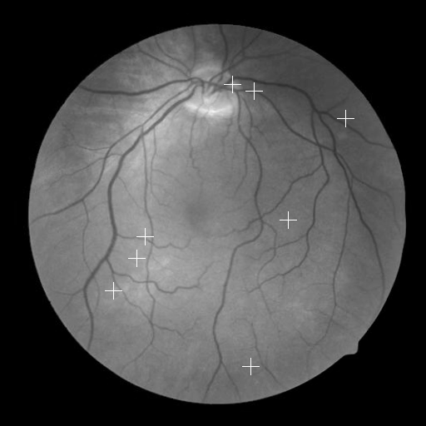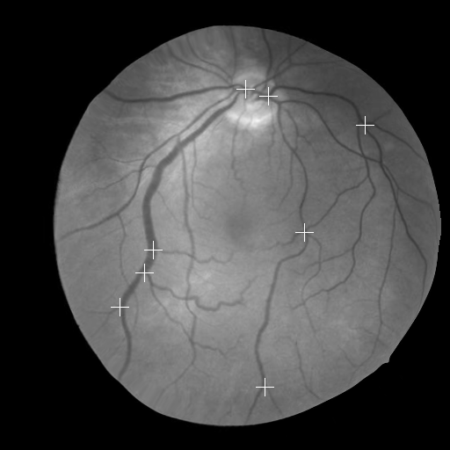

Fig. 1(d) Fig. 1(e) Fig. 1(f)

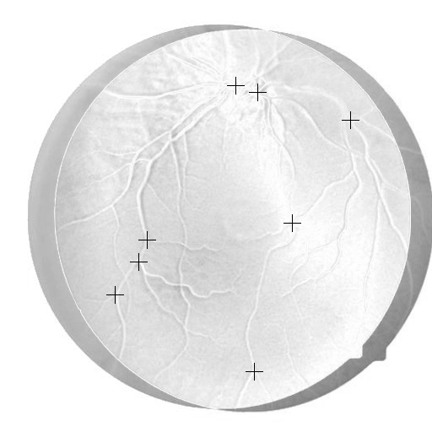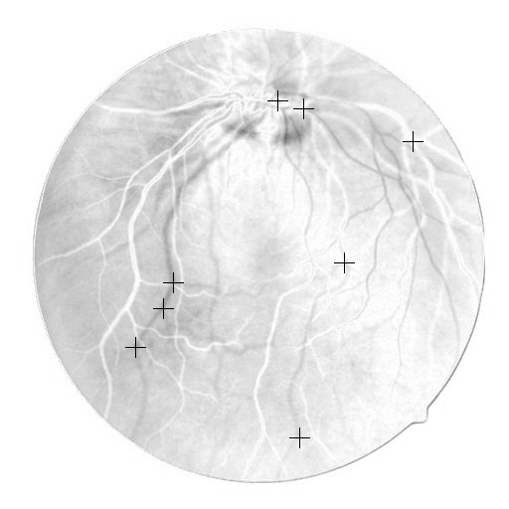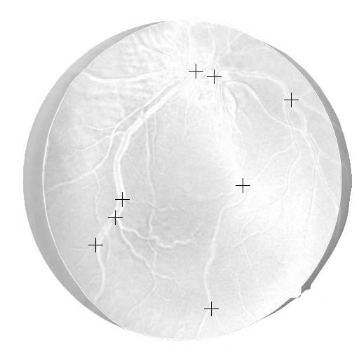

Fig. 1(g) Fig. 1(h) Fig. 1(i)

Figure captions:

Registration results for fluorescein angiography of a human eye.

1(a): reference with 8 landmarks,

1(b): template with 8 landmarks

1(c): difference between and

1(d): template after landmark based registration

1(e): template after intensity based registration

1(f): template after CoLD based registration

1(g): difference after landmark based registration

1(h): difference after intensity based registration

1(i): difference after CoLD based registration

