McMaster University  Risk Management    Manual | RMM #500  Designated Substances Control Program | Final  Date: July / 03  Page: A-1
Appendix A Designated Substance Assessment Form
RECORD OF DESIGNATED SUBSTANCE ASSESSMENT
The help and hidden comments are referenced from “Workbook for Designated Substance Assessments” from Industrial Accident Prevention Association (IAPA). If you wish to hide the hidden text, go to the Tool option on the main menu, pick Options and uncheck the Hidden Text box. If there is help for input area, press F1 to see the help. Not all input areas have help.
SUBSTANCE: | Silica Sand
DATE REVIEWED BY JHSC: | 11th March 2015

COMPANY: | Mechanical Engineering Department, McMaster University
DEPARTMENT OPERATIONS:
Light Metal Casting Research Center (LMCRC)-JHE 101
Mechanical Engineering
LOCATION(S):
Dry sand mixing with water: JHE loading dock

Wet sand for mold preparation: Light Metal Casting Research Center (LMCRC)-JHE 101
Department of Mechanical Engineering, McMaster University

ASSESSMENT PREPARED BY:
Jeyakumar Manickaraj

JOB TITLE:
Research Associate
DATE PREPARED: |  | July 21st, 2014

APPLICATION – WORKSHEET 1: IS THE DESIGNATED SUBSTANCE PRESENT?
The first two worksheets deal with the application of the regulation. It is an initial appraisal of your situation. It will help you decide whether the regulation applies to your workplace and whether you require the written assessment covered in Section III.
1. Do any material safety data sheets from your suppliers indicate the presence of the substance?
 | YES |  | × | NO
2. If substance is present, indicate the department where it is used, nature of the use (i.e. Direct or Indirect) and the quantity used per month or year:

Product Name |  | Department |  |  | How Used?  Direct/Indirect |  |  | Quantity  Per Month/Year
Silica Sand |  | Light Metal Casting Research Center (LMCRC)-JHE 101 Mechanical Engineering |  |  | direct |  |  | 50 lb/month

CONCLUSIONS
Read statements and check applicable box:
Substance not present anywhere in workplace; regulation does not apply.
No Assessment needed. (Note: Although you do not need to proceed further, you should retain this worksheet on record. e.g. auditing purposes)
Processes / activities have been identified where substance present.
Proceed to Worksheet 2.
X

APPLICATION – WORKSHEET 2: IS WORKER EXPOSURE LIKELY?
1. In what form does the substance enter the plant? Sand Particles filled in paper bags placed in plastic container
Product title: |  |  |  |  |  | Silica Sand Premixed with 6% water
Type of Container: |  |  |  |  |  |  | Reinforced Paper Bags placed in a plastic container |  |  |  |  |  |  |  | Size of Container: |  |  |  |  |  |  |  | 22 kg weight
2. Is this form altered during use or in the operation? |  |  |  |  |  |  |  |  |  |  |  |  |  |  |  |  |  |  |  |  |  | YES | X |  | NO
If YES, indicate altered form: |  |  |  |  |  |  |  |  |  | Silica sand mixed with water
3. Is there a possibility of the substance being released into the workspace environment during normal use?
 |  |  |  |  |  |  |  |  |  |  |  |  |  |  |  |  |  |  |  |  |  | YES |  |  | NO |  |  | X
If YES, indicate the stage of the operation or areas where this can occur:

- If YES to Question 3, specify the job functions and approximate number of employees who might be exposed:
Job Function |  |  |  |  |  |  |  |  |  |  |  |  |  |  |  |  |  |  |  |  | Number of Employees
5. If YES to Question 3, indicate how workers could be exposed:
 |  |  | Inhalation |  |  |  |  |  |  |  | Ingestion |  |  |  |  |  |  |  |  |  |  | Skin Absorption
 |  |  | Skin Contact |  |  |  |  |  |  |  | Other
6. If NO to Question 3, is there a likelihood of escape due to leaks, accidents, etc.?
 |  | YES |  |  |  |  |  | NO |  |  |  | ×
7. Are workers likely to be exposed? |  |  |  |  |  |  |  |  |  |  |  |  |  |  |  | YES |  |  |  |  |  |  | NO |  | ×

CONCLUSIONS
Are there any activities/situations where exposure by any route is likely?
YES | x |  | NO
If NO, no further action is necessary. Date completed |  |  |  |  |  | July 21st, 2014.
If YES, an assessment is necessary – proceed to Section III.
Note: If protection against exposure has been left up to some engineering control measure which can fail, or deteriorate for any reason, or to a work hygiene practice, an assessment is necessary – Proceed to Section III.

ASSESSMENT – WORKSHEET 3: PROCESS DESCRIPTION

NAME OF PROCESS:

 | Process Flow |  | Description | Likely Exposure  Yes/No
1. | Moving dry sand to JHE |  | Keep sand bag in a closed plastic container during transport from CANMET Materials,, where Sand is stored to JHE where mold is to be prepared and used. The silica sand will be stored in JHE101 in a closed container and workplace label will be displayed as “silica sand-do not open”. | No
2. | Mixing sand with water |  | Dry sand kept in a plastic container is moved to JHE loading dock and mixed with water with proper handling | Yes
3. | Wet Sand brought back to JHE 101 |  | Wet sand placed inside a plastic container and moved to JHE 101 | No

 |  |  | Mixing water based binder with sand  Amount of binder in the sand:  3.0% →Sodium dihydrogen Phosphate monohydrate ACS 98.0-102.0%  6.0% → Calcium Bentonite  3.0% → Plaster of Paris  3.0% →Borax | No
4. | Mixing wet sand with binder |  |  | No
 |  |  | Packing sand in mold box  Curing mold by heating | No
5. | Mold preparation/curing |  | Packing sand in mold box  Curing mold by heating | No
 |  |  | Wet sand will be packed in a closed container and transported to CANMET for disposal | No
6. | Moving wet sand to Canmet Materials lab |  |  | No

ASSESSMENT – WORKSHEET 4: EXISTING CONTROLS
you have identified in the previous worksheet (Worksheet 3).
Process Flow Stage | Control Description | Problems/Recommendations
1 | Engineering Controls:  Sand bag placed inside a closed plastic container, it is not exposed to atmosphere
1 | Work Practices:  NA
1 | Hygiene Facilities and Practices:  NA
1 | Training Information:  NA
1 | Personal Protective Equipment  NA
1 | Emergency Procedures/Equipment  NA

Process Flow Stage | Engineering Controls:  Plastic container with sand taken to loading dock area and confirmed that there is no one else around in that area before opening the container. The person working with sand has to cover himself with overall clothing (protective layer) and mask (Mask 3m 6200). Pour sand into bucket by a small laminar stream with no turbulence or dissipation and add water After mixing sand with water the wet sand is taken to JHE 101. The person removes his protective layers (protective clothing will be reused), puts in a bag and seals it before moving out of the loading dock area. This bag will be stored in JHE 101 and re-opened only in the dock area. | Problems/Recommendations
2 | Work Practices:  Wear protective layers on top of your clothes to avoid contact with silica sand
2 | Hygiene Facilities and Practices:  Eye wash located in front of JHE 107/Hand wash station located in front of JHE 107/Washrooms located in front of JHE 103
2 | Training Information:  Training provided by CANMET laboratory, Hamilton
2 | Personal Protective Equipment  Safety goggles, Fitting masks (Mask 3m 6200) for dust protection, nitrile gloves
2 | Emergency Procedures/Equipment  NA
2 | Engineering Controls:  Pour sand into bucket by a small laminar stream with no turbulence or dissipation. Then add water to mix it.

Process Flow Stage | Engineering Controls:  Wet sand moved back to JHE 101.  Follow SOP for mold preparation and wet sand handling. The SOP is available in JHE101 near the double door. | Problems/Recommendations
3 | Work Practices:  Wear mask 3M-6200 and nitrile gloves
3 | Hygiene Facilities and Practices:  Eye wash located in front of JHE 107/Hand wash station located in front of JHE 107/Washrooms located in front of JHE 103
3 | Training Information:  Training provided by CANMET, Hamilton for mold preparation and wet sand handling
3 | Personal Protective Equipment  Safety goggles, Fitting mask 3M 6200 for dust protection, nitrile gloves
3 | Emergency Procedures/Equipment  Eye wash located in front of JHE 107/Hand wash station located in front of JHE 107/Washrooms located in front of JHE 103
3 | Engineering Controls:

ASSESSMENT – WORKSHEET 5: JOB EXPOSURE ANALYSIS
This worksheet identifies the type and number of workers who may be exposed to the substance because of the nature of their job tasks in relation to the process. Do not forget to consider indirect process-related tasks such as cleaning, maintenance, warehousing, etc…
Process Flow Stage | Job Title | Total Number of Employees | Tasks Where Exposure Likely | Duration Hrs per Week | PPE Req'd to be Used
1 | Transferring sand from bag to bucket and mixing with water | 1. Kifah Takrouri  2. Satyam Sharma  3. Aykut Dursun  4. Sumanth Shankar | Mixing of sand and water | 10 minutes | Pre-fitted dust mask.

2

CONCLUSIONS
Jobs/tasks to be noted during walk-through survey:
ASSESSMENT – WORKSHEET 6: HEALTH EFFECTS
may be related to the presence of the substance in the workplace. It is also to identify and record any existing medical program which you have in your workplace.
1. Any reported health effects? If so, describe.
No.
2. Any current Medical Program? If so, describe.
No.
3. Previous exposure monitoring effects? If so, describe.
No.

CONCLUSIONS
Health effects known at this stage: | YES |  |  | NO | ×
Further information required: | YES |  |  | NO | ×

ASSESSMENT – WORKSHEET 7: FLOOR PLAN

LOCATION: | Light Metal Casting Research Center (LMCRC)-JHE 101  Mechanical Engineering |  | DATE: | 21 July2014

Unfortunately, you cannot draw here. Create your drawing and save it as a picture. Highlight this text and go to the Insert Menu and insert the picture.

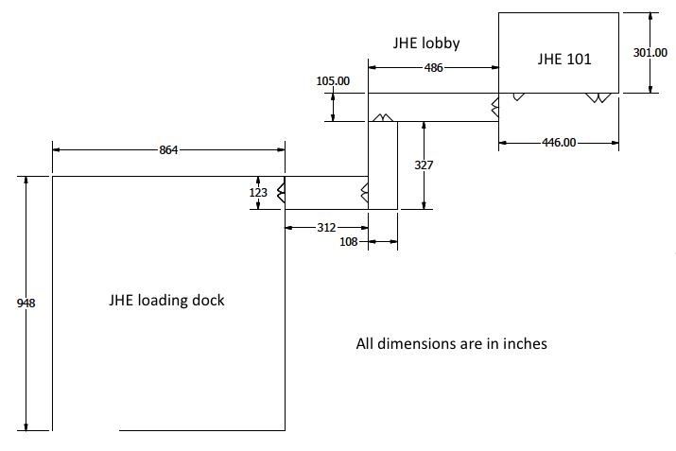
Floor plan for JHE loading dock area to JHE101

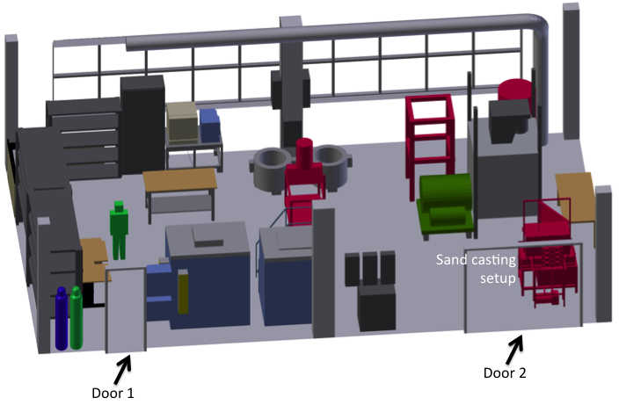

JHE 101 Floor plan
DIMENSIONS: |  | L | 446 inch |  | W | 301 inch |  | H | 150 inch

ASSESSMENT – WORKSHEET 8: WALK THROUGH
The walk through is used to confirm the information gathered. Used the previous worksheets to help you with your walk through. Here are some other notes: 1) Observe any spills, fumes, vapours, mists or smells; 2) The time in which the walk through is done, try to do it when the substance is in use; 3) Make sure supervisors and workers are aware of the purpose of the walk through.
Evidence of Contamination:
Hygiene Facilities and Work Practices:
Ventilation Systems:
Storage Facilities:
ASSESSMENT – WORKSHEET 8: WALK THROUGH (cont.)
Dispensing Procedures:
Housekeeping:
Personal Protective Equipment:
Emergency Facilities / Procedures:
ASSESSMENT – WORKSHEET 9: WALK THROUGH CONCLUSIONS
tify and compile any concerns you have in controlling the substance.
1(a). Were any areas found where controls are required or where existing controls may require improvement?
 | YES |  |  | NO |  | X
1(b). If YES, indicate the areas where the controls may be required or where existing controls may require improvement.
AREA |  |  |  |  | SUGGESTED IMPROVEMENTS
2(a). Personal exposure monitoring is required: |  |  |  |  |  |  |  | YES |  |  | NO | X
2(b). If YES, indicate where:
3. Indicate any workers for whom medical testing and/or examinations may be required.

CONCLUSION – WORKSHEET 10: IS A CONTROL PROGRAM NECESSARY?
CONCLUSION A: NO WORKER’S HEALTH MAY BE AFFECTED.
CONCLUSION B: A WORKER’S HEALTH MAY BE AFFECTED.

OVERALL CONCLUSION
A control program is necessary |  |  | YES |  |  |  |  | NO
Improvements needed in existing program:
DATE: |  |  |  | SIGNED:

